- Purpose

The purpose of this document is to describe a new process in the ClearView software that will allow the exporting of data to be expedited.

- Scope

The scope consists of the ClearView Quick Export as a whole, no other systems requirements are defined in this document. The initial release of this document addresses only the requirements for the core system, this will be augmented as new requirements are introduced.

- Definitions

Capture Search Results | The search results page that appears when searching for all captures.  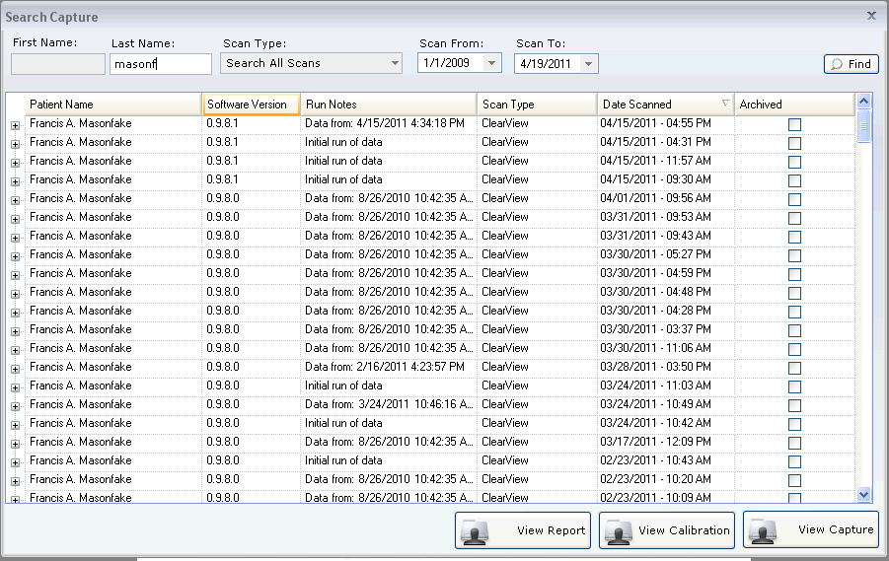

- System Requirements

- This functionality should only be available to administrators.
- Add a button to the Capture Search Results dialog that can be used to start an export of a subject's data.
- A button should appear for each search results row that appears in the Capture Search Results dialog.'
- The export process should allow the exporter to choose the destination location for the files to be saved.
- The base folder that should be created for the export will follow this naming convention: {Subject Id}_Date and time of scan
- The process should export the following for the given scan that was selected.
  - Calibration Images
  - Energized Images (Filtered and Unfiltered)
  - Finger Images (Filtered and Unfiltered, if available)
  - The raw data for the calculation (in csv format)
  - The report data
- Within the folder selected, create the following folder directory structure:
\CalibrationImages
\FingerImages
\EnergizedImages
\RawData
\ReportData
- Clicking the button should cause the following actions
- Display the output directory selection dialog
- Export the data into the folder selected
- Display a completion confirmation dialog.

Document Revision History
Version Number: | Description of Change: | Date: | Updated by:
000 | Introduction | 5/24/11 | A. Mason

